PhET Simulation: Projectile Motion
Name_____________________________________ Date _____________
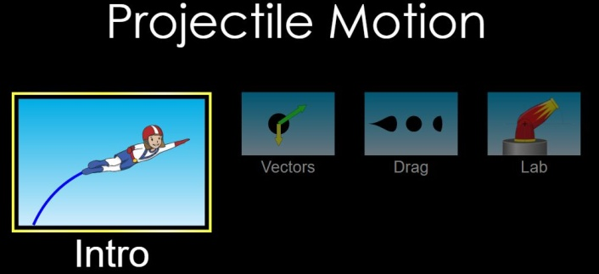
Go to PhET simulations using the link https://phet.colorado.edu/en/simulation/projectile-motion. Select the Intro icon.
Begin with the default settings of:
Cannon angle 0⁰ Target distance 15 m
Cannon height 10 m Initial speed 15 m/s
Object Pumpkin

Check the Velocity and Acceleration Vectors boxes. DO NOT check the air resistance box.
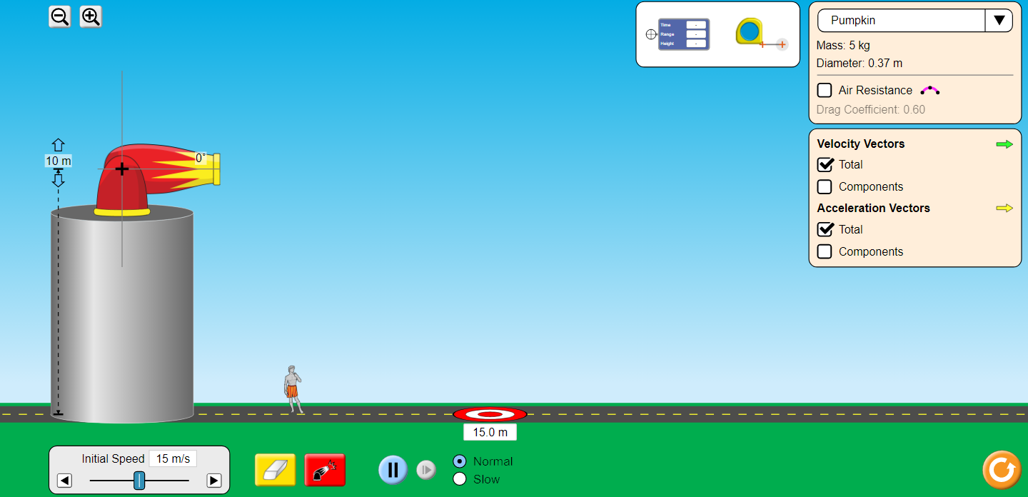

- Use the red launch icon at the bottom of the screen to fire the cannon. The pumpkin misses the target. Does the pumpkin overshoot or fall short?

- Now adjust the cannon height until you successfully hit the target. Record the height below. Return the cannon height back to 10m. Next, adjust the object (pumpkin) until you successfully hit the target. Record the velocity below. Return velocity back to 15 m/s. Lastly, adjust the angle of the cannon until you successfully hit the target. Record angle below.

New height of cannon (to hit target)_____m

New initial velocity (to hit target)_____m

New angle (to hit target) = _________m

Explain how each variable affects the range of the object

- A. Set the cannon’s height to 0 meters and the initial speed to 20 m/s. Find the angle that gives you the maximum range. Record this angle below.

Angle for maximum range (with cannon at zero height) = ________degrees

B. Reset the angle to 20 degrees and fire cannon. Find the angle that gives you the same range.

Angle that gives the same range as 20 degrees________ degrees.

Reset the cannon height to 15m. Find the angle that gives you the maximum value. Record this value below.

Angle of maximum range (cannon at non zero height) = ______ degrees

- Move the cannon’s height to zero. Set the angle to 90 degrees. Choose some arbitrary starting velocity If the object leaves the screen, change scale using the ‘minus’ icon so that the fired object remains in your field of view.

Fire the cannon and use crosshairs icon to find the maximum height. Record the initial velocity and maximum height below. Next, increase the starting velocity by a factor of two (2). Fire again and find maximum height again. Record this value below.

initial velocity of object ______m/s Maximum height of object at initial velocity =_______m

2 x initial velocity of object = ____m/s Max height of object at 2 x initial velocity =_______m

- Based upon what you observed in question 3 above, how would you answer the question “what angle gives the maximum range for a projectile?”.

- Based upon what you observed in 3B above (different angle but same range), which object stayed in the air longer? Which object had the greater kinetic energy at the maximum height? Explain.

- Based upon what you observed in question 4 above, what can you say about the relationship between initial velocity and maximum height? Explain using energy considerations from Work and Energy experiment.

